Error que me sale:
{"error":{"type":"error.SuiteScriptError","name":"INSUFFICIENT_PERMISSION","message":"Permission Violation: You need the 'Lists -> Customers' permission to access this page. Please contact your account administrator.","id":"","stack":["createError(N/error)","getUPSShippingLabel(/Web Site Hosting Files/Live Hosting Files/SSP Applications/NetSuite Inc. - SCS/SuiteCommerce Standard2/extensions/NSeComm/UPSShippingLabel/1.0.0/Modules/Main/SuiteScript2/UPSShippingLabel.Model.js:67)","service(/Web Site Hosting Files/Live Hosting Files/SSP Applications/NetSuite Inc. - SCS/SuiteCommerce Standard2/extensions/NSeComm/UPSShippingLabel/1.0.0/Modules/Main/SuiteScript2/UPSShippingLabel.Service.ss:25)"],"cause":{"type":"internal error","code":"INSUFFICIENT_PERMISSION","details":"Permission Violation: You need the 'Lists -> Customers' permission to access this page. Please contact your account administrator.","userEvent":null,"stackTrace":["createError(N/error)","getUPSShippingLabel(/Web Site Hosting Files/Live Hosting Files/SSP Applications/NetSuite Inc. - SCS/SuiteCommerce Standard2/extensions/NSeComm/UPSShippingLabel/1.0.0/Modules/Main/SuiteScript2/UPSShippingLabel.Model.js:67)","service(/Web Site Hosting Files/Live Hosting Files/SSP Applications/NetSuite Inc. - SCS/SuiteCommerce Standard2/extensions/NSeComm/UPSShippingLabel/1.0.0/Modules/Main/SuiteScript2/UPSShippingLabel.Service.ss:25)"],"notifyOff":false},"notifyOff":false,"userFacing":false}}
Crear nuevo rol, y luego:
Nombre: el que quiera
Center type: Classic Center

Una vez creado y guardado el rol, tendremos que ir al archivo del servicio para darle permisos con este nuevo rol, para esto:
Entrar al archivo del servicio “UPSShippingLabel.Service.ss”, editar y en la sección de permission, chequear ENABLED, y elegir nuestro rol creado en “execute as role”.
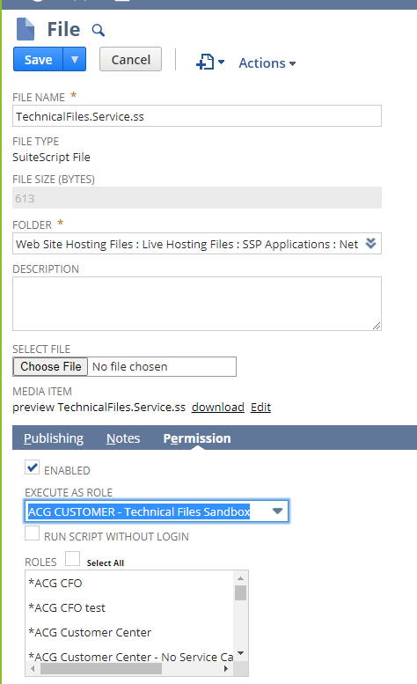
Le damos check a todos los checkboxes de all roles, all employee, y all partner.

